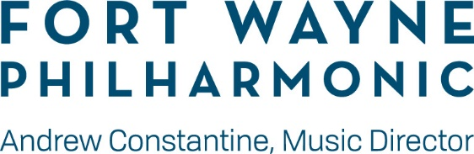
Youth Orchestra Auditions
Teacher Recommendation Form
Please bring completed recommendation form with you to your scheduled audition.

Student Information:

Name __________________________________________ Instrument ________________________________________________

Please list music currently in student’s repertoire and/or indicate level of study:
_________________________________________________________________________________________________________________________________________________________________________________________________________________________________________________________________________________________________________________________________

To help determine appropriate placement, please rate the student on each of the following criteria. Circle one.

Very Poor Poor Fair Good Very Good
Regular lesson/class attendance 1 2 3 4 5

Preparedness 1 2 3 4 5

Leadership Skills 1 2 3 4 5

Proficiency of Sharps and Flats 1 2 3 4 5

Range Ability (Winds and Brass students) 1 2 3 4 5

Musical Potential 1 2 3 4 5

Please describe the student’s ability to do transpositions and read different clefs: (if applicable)
_________________________________________________________________________________________________________________________________________________________________________________________________________________________________________________________________________________________________________________________________

Please describe why you feel this student would be a great asset to the Fort Wayne Philharmonic’s Youth Orchestra program. Please be specific regarding the student’s ability and commitment.
_________________________________________________________________________________________________________________________________________________________________________________________________________________________________________________________________________________________________________________________________

Teacher Information

Name _______________________________________________________________________________________________________

Address _____________________________________________________________________________________________________

Email _____________________________________________ Phone ____________________________________________________

Are you the student’s private music instructor or school music teacher? _________________________________________________

Signature __________________________________________ Date _____________________________________________________

