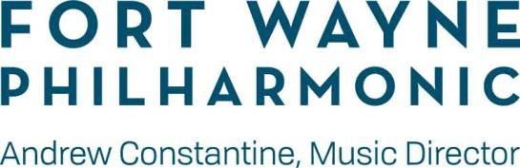
Fact Sheet

Music Director: Andrew Constantine
Guest Conductor for Engagement: Caleb Young Chorus Director: Benjamin Rivera
Director, Youth Orchestras Program: Troy Webdell President and CEO: Brittany A. Hall

Board Information:
The Fort Wayne Philharmonic is governed by a 31-member Board of Directors and has an annual operating budget of $5-6 million.

Rick James – Chair Jonathan Hancock – Vice Chair
Ben Eisbart Dan Nieter – Vice Chair
Kyle Farmer – Secretary Judy Pursley – Vice Chair
Mary Fink – Treasurer Chuck Surack – Immediate Past Chair

About the Fort Wayne Philharmonic:
Now in its 79th season, the Fort Wayne Philharmonic is one of the most exciting performing arts organizations in Indiana. The Philharmonic’s mission is to foster and instill a lifelong love of music across the orchestral spectrum through live performances and educational experiences.. Led by Music Director Andrew Constantine, Philharmonic performances reach more than 200,000 people every season at the historic Embassy Theatre, Auer Concert Hall, and at various venues throughout the community, including schools, nursing homes, community centers, and churches. The Fort Wayne Philharmonic is truly an orchestra of the future, with bold plans to reach deeply into the fabric of the community with exciting, entertaining, and meaningful offerings. The Philharmonic reaches more than 39,000 young people and families through its extensive education and community engagement programs, including Ensembles in the Schools, Young People’s Concerts, and Club Orchestra - a novel El Sistema modeled collaborative program with three Fort Wayne Community Schools - inspiring and motivating young citizens of the future. Regional touring, donor cultivation, and Board activities round out a busy schedule for the orchestra.

Recordings:
In 2018 the FWP recorded, under the direction of Music Director Andrew Constantine, Walter Bricht: Orchestral Music, Volume One, produced by GRAMMY Award-winning producer Tim Handley for the British label Toccata Classics. The CD consists of three pieces composed by the Austrian-American composer: Symphonic Suite in A minor, Op.25; Verwehte Blätter (Scattered Leaves’): Eight Small Pieces for Orchestra, Op. 18b; and Symphony in A minor, Op. 33.

Address:
Fort Wayne Philharmonic 4901 Fuller Drive
Fort Wayne, IN 46835

Telephone:
260.481.0770 – main office 260-422-4226 – ticket office

Website:
FWPHIL.ORG

