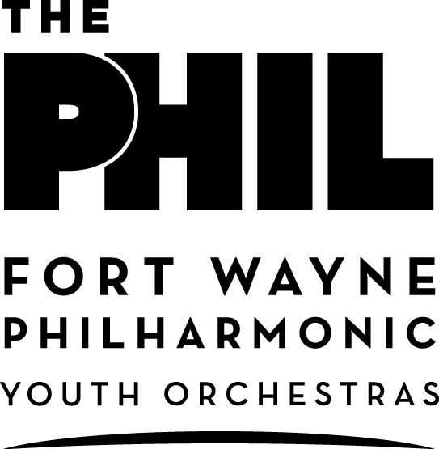

Student Information

Name: ________________________________________________________ Gender: ___________
First Last M/F

Home Address:_____________________________________________________________________________
Street City State Zip

Instrument: ___________________________________ Total Years of Study: _________________

Please list the solo piece you will be performing for your audition:

Title: _______________________________________ Composer: __________________________

Parent/Guardian Information

Name: _________________________________________________________________________________________
First Last

Address (if different than above): _______________________________________________________________________
Street Address City State Zip

Email: __________________________________ Contact Phone: ______________________

Current Private Teacher

Name: ________________________________________________________________________________
First Last

Current School Information

School Name: ______________________________________________________________________________

Grade Level For Upcoming School Year: _____

*To secure your audition time, please return completed application along with a non-refundable $25.00 per family audition fee by May 15. Make checks payable to the Fort Wayne Philharmonic and send to:
Fort Wayne Philharmonic
4901 Fuller Drive
Fort Wayne, IN 46835
ATTN: Joseph Kalisman, Youth Orchestra Manager

